**Group 10 :**

**Members**:

**Name: DIP, FAZLA IMAM**

**Id: 19-40354-1**

**Name: NARESH, BARUA**

**Id: 19-40332-1**

**Name: METHILA, FARZANA**

**Id: 19-39692-1**

**Online Rating System (RateIT)**

**Use case diagram:**

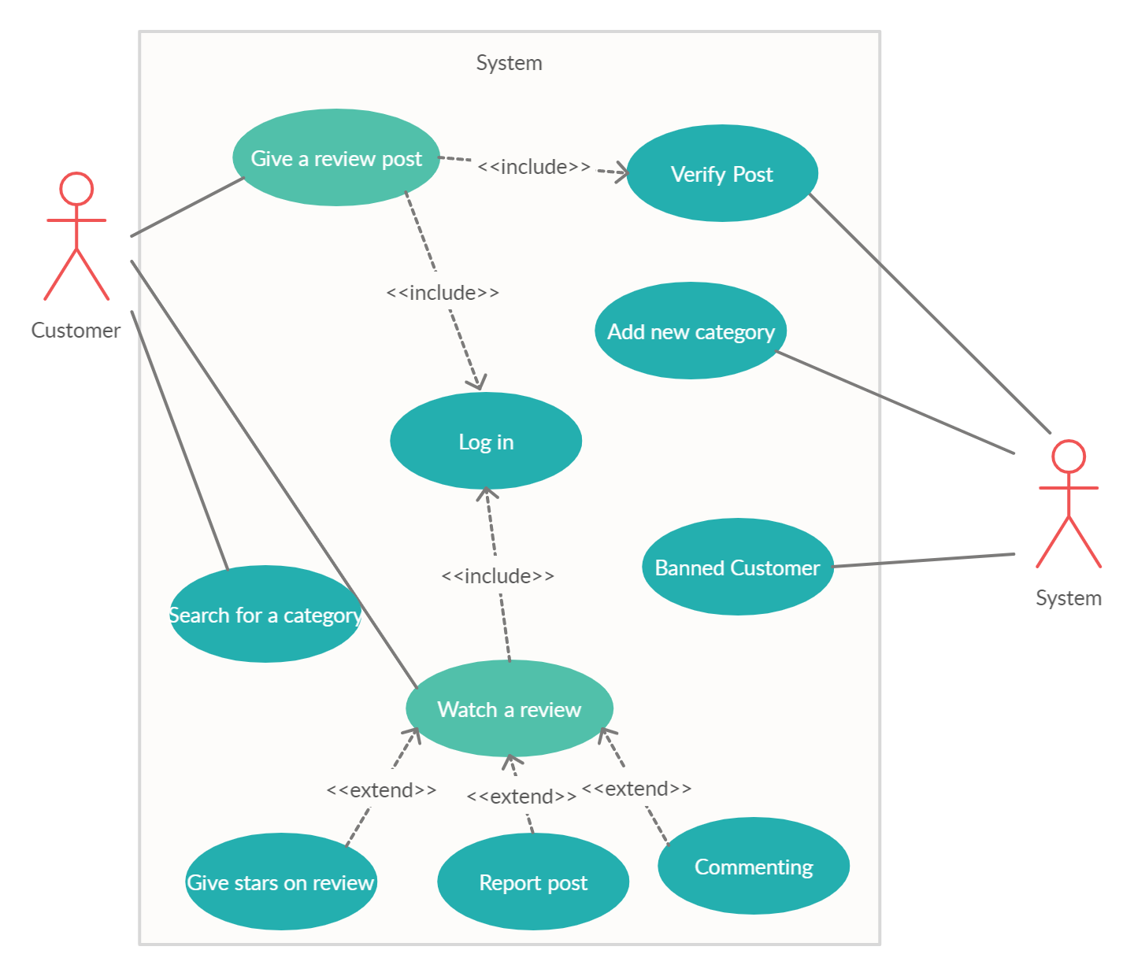

**Mock design**





